Report HW 6 ECE-111
Name: Jasper Huang
PID: A17796149

Homework 6a (Vending Machine)

Mealy FSM
- SystemVerilog design code
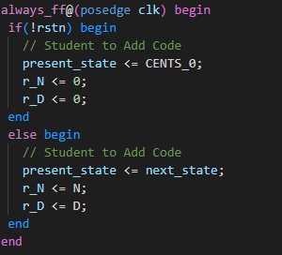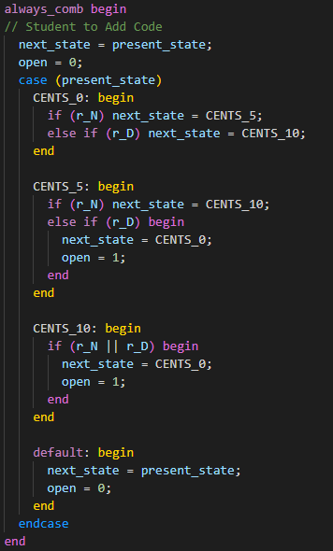

- Synthesis resource usage and schematic generated from RTL netlist viewer
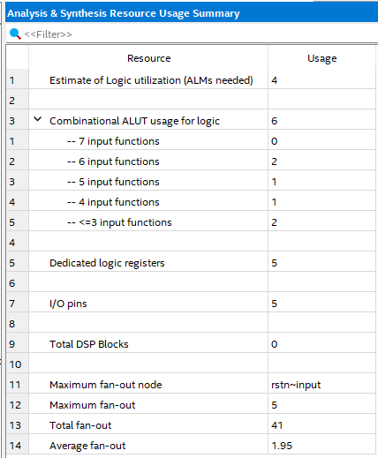
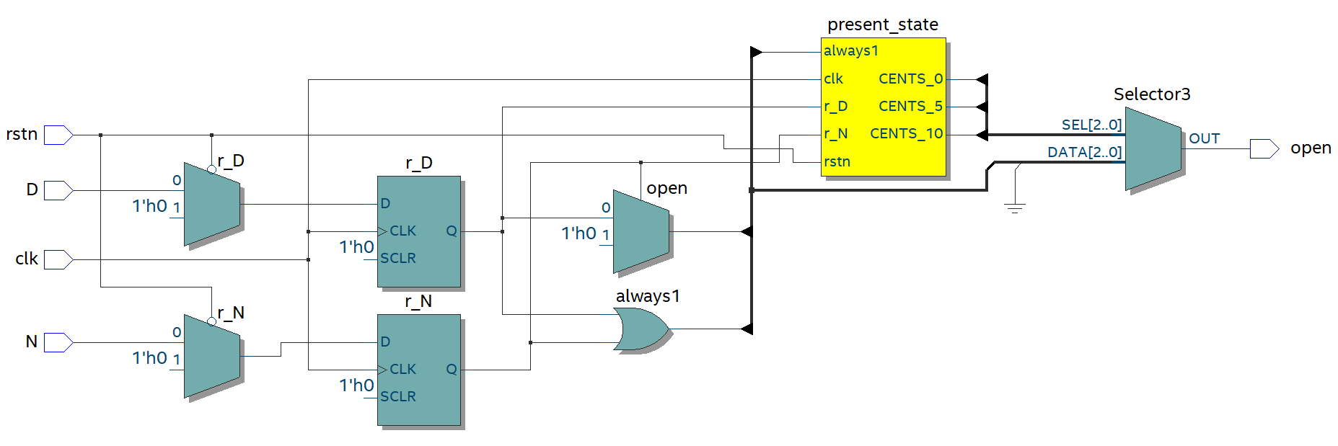

- Simulation snapshot and explain simulation result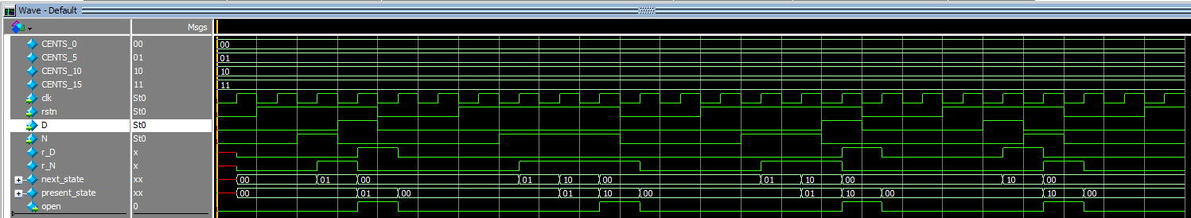
The simulation wave form shows after inserting Nickle or Dime (High N or High D), the state changes and as it reaches a total of 15, the open flag is high. The implementation remove the state CENTS_15 as it’s unnecessary for the vending machine. The open flag is set correctly for the input D and N.

Moore FSM
- SystemVerilog design code
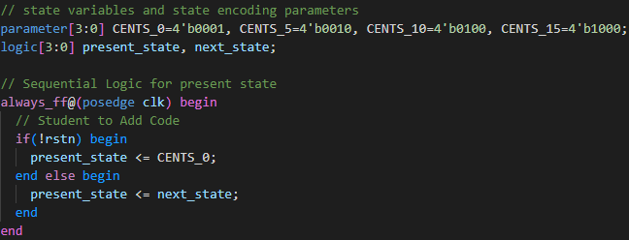
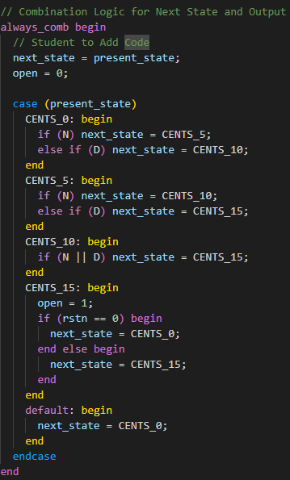

- Synthesis resource usage and schematic generated from RTL netlist viewer
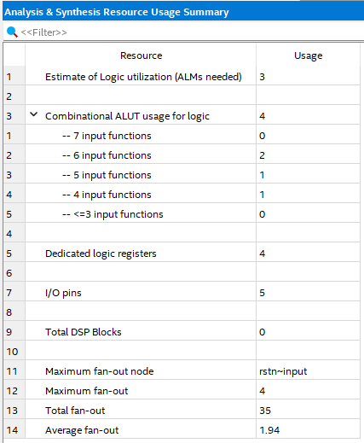
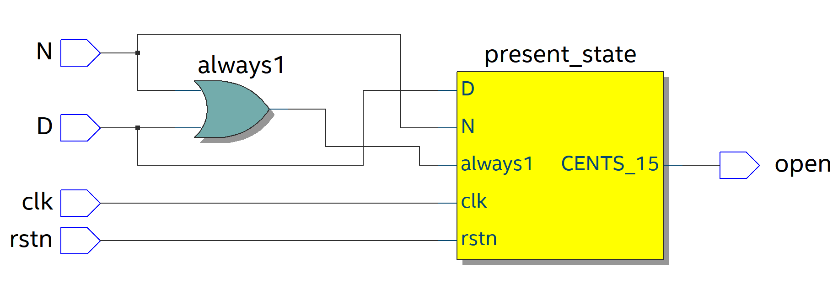

- Simulation snapshot and explain simulation result
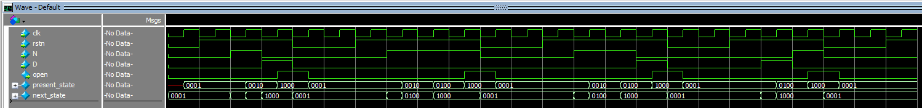
The simulation wave form shows after inserting Nickle or Dime (High N or High D), the state changes and as it reaches a total of 15, the open flag is high. The open flag is set correctly for the input D and N. The present state also correctly reflects on the previous next state.

- FSM state transition diagram
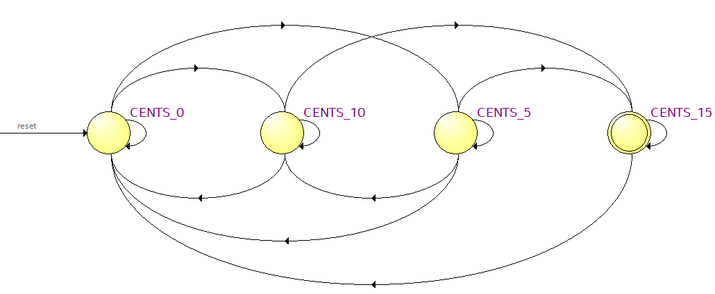
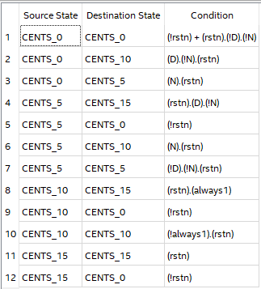

Homework 6b (Integer Multiplier)

SystemVerilog FSM design code (Student Added Parts)
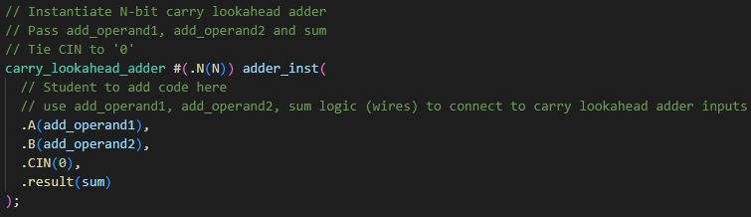
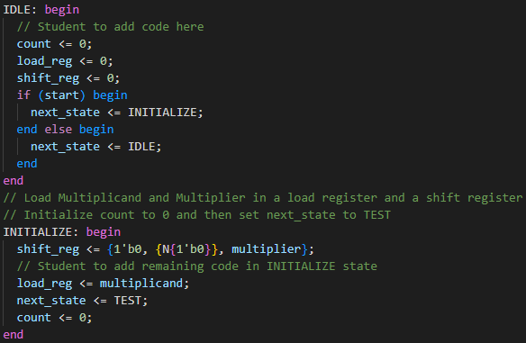
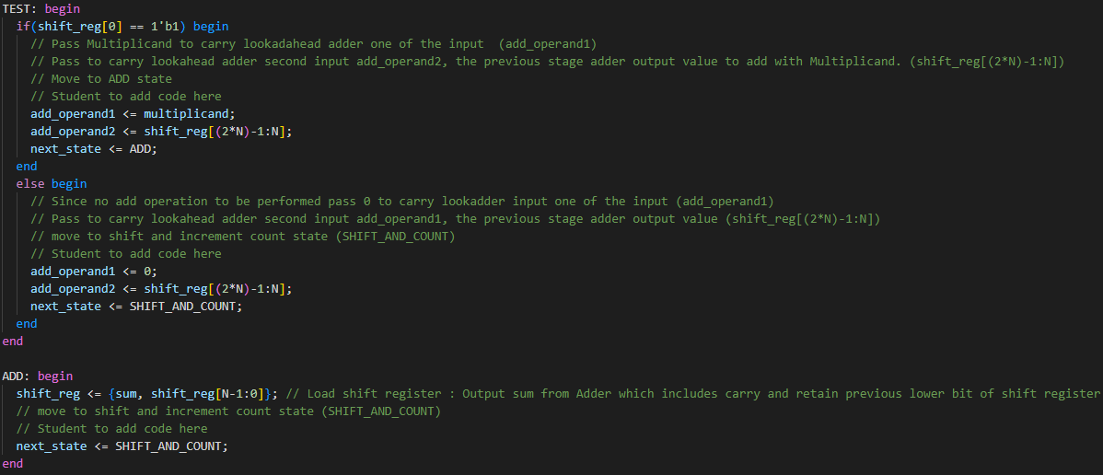
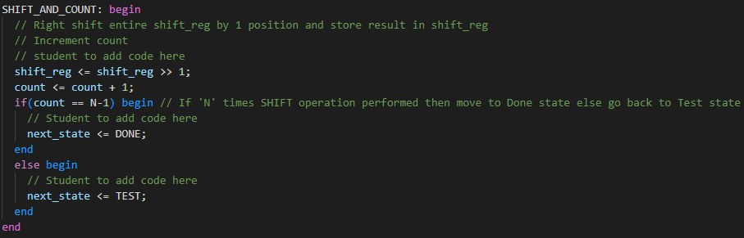

State Transition Diagram
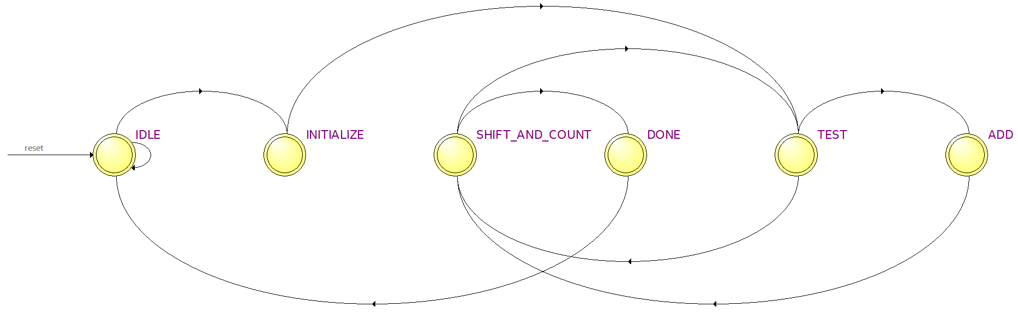

State Transition Table
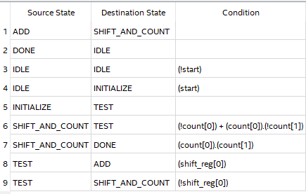

Synthesis resource usage
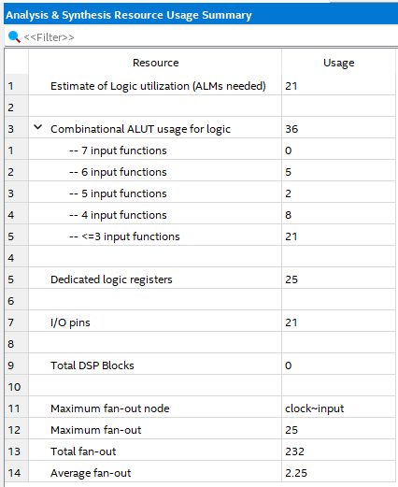

RTL netlist viewer
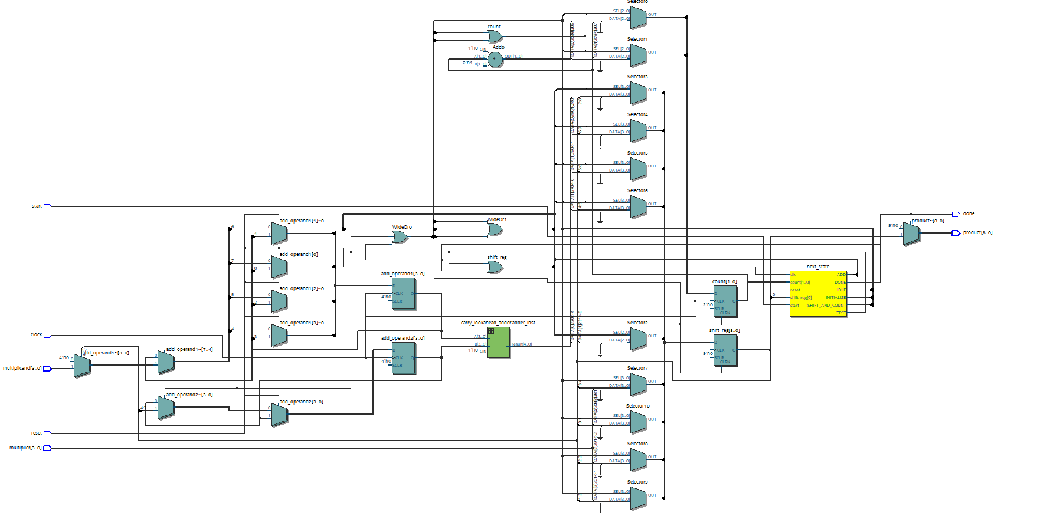
Simulation snapshot & Transcript & Explanation
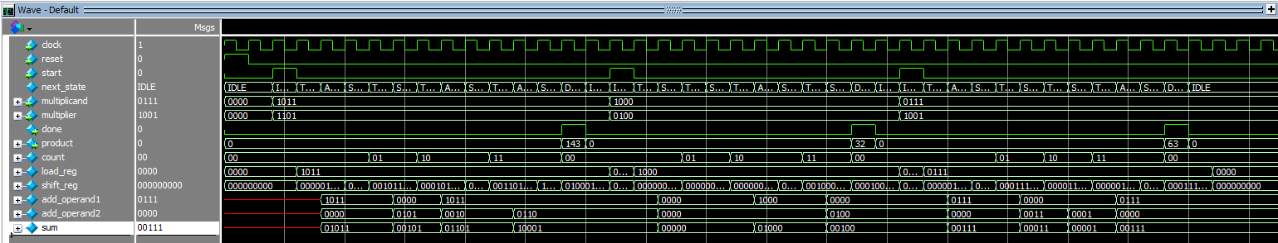
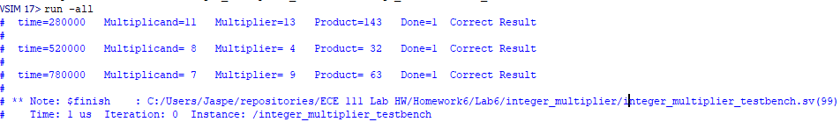
The simulation result shows the transition between 6 states. The load_reg and shift_reg also changes correctly based on the correct operation determined in the TEST stage and the output from the carry_lookahead_adder. The state changes in between TEST ADD SHIFT_AND_COUNT according to the TEST result and continue until the product is calculated and the done flag is up once the cycle finished. The entire simulation produce three products which are correct based on the input multiplicand and multiplier.

Homework 6c (Integer Multiplier)

SystemVerilog FSM design code (Student Added Parts)
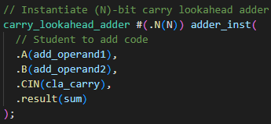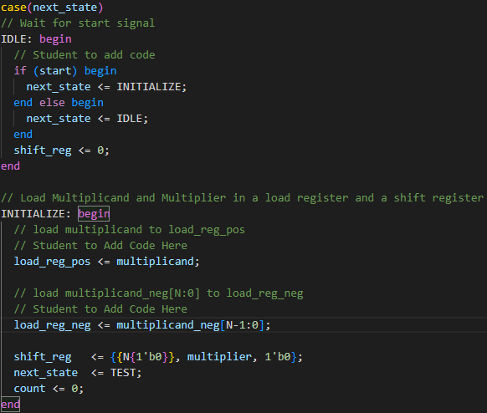
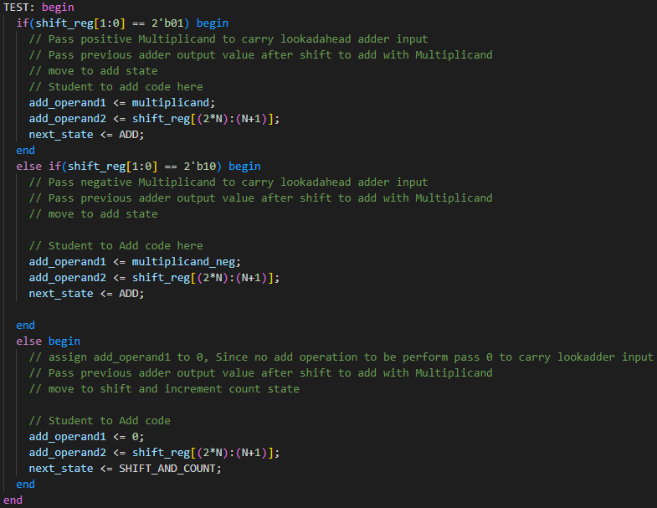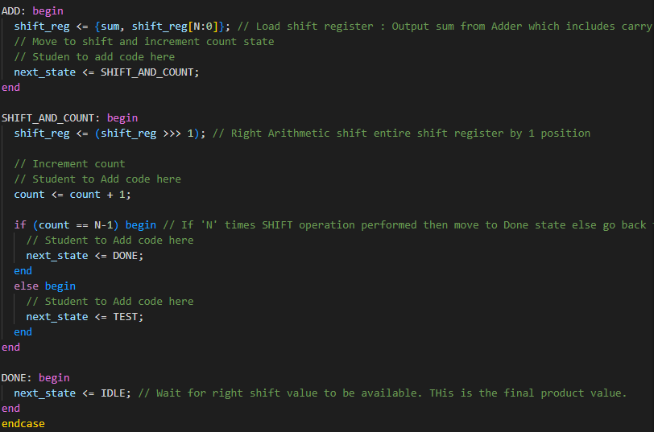

State Transition Diagram
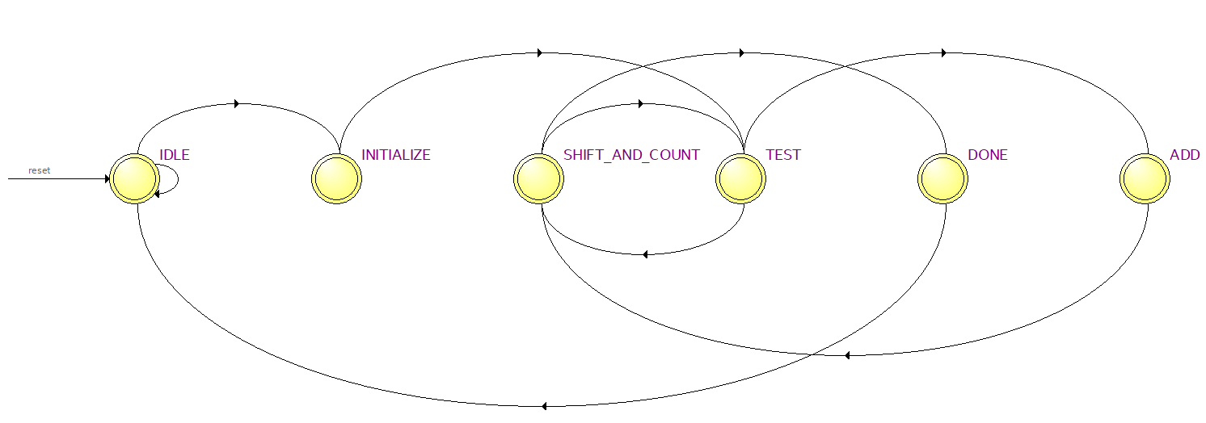
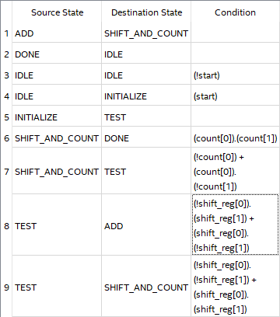
Synthesis Resource Usage
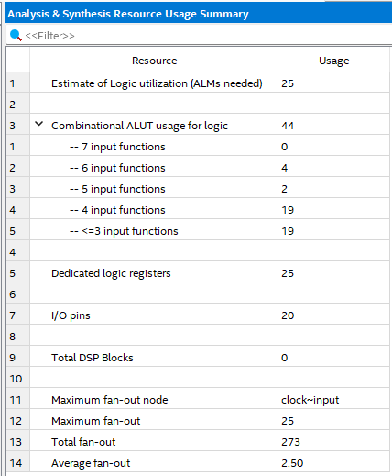

RTL netlist viewer
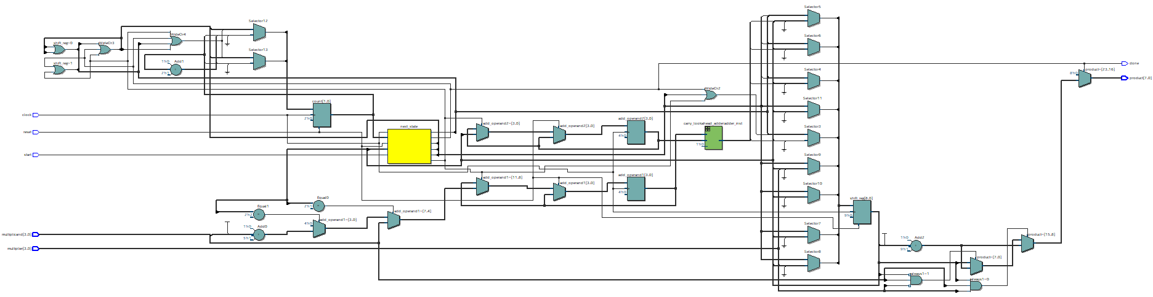

Simulation snapshot & Explanation & Transcript
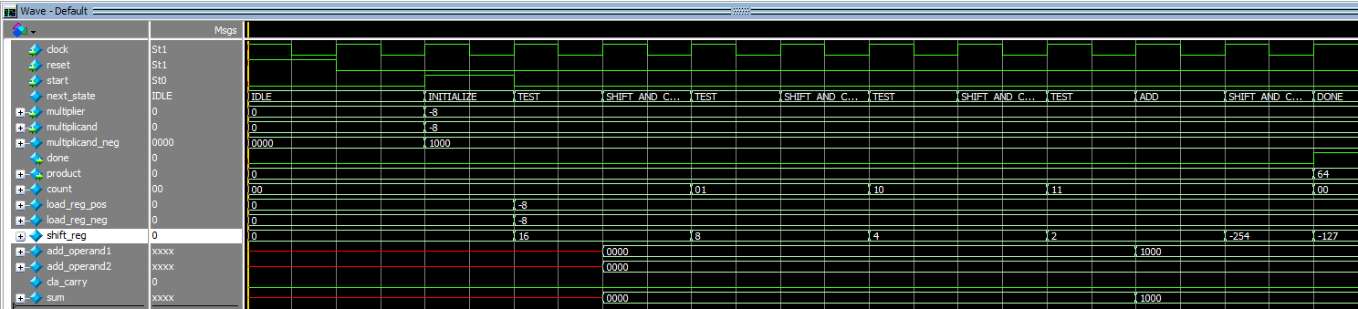
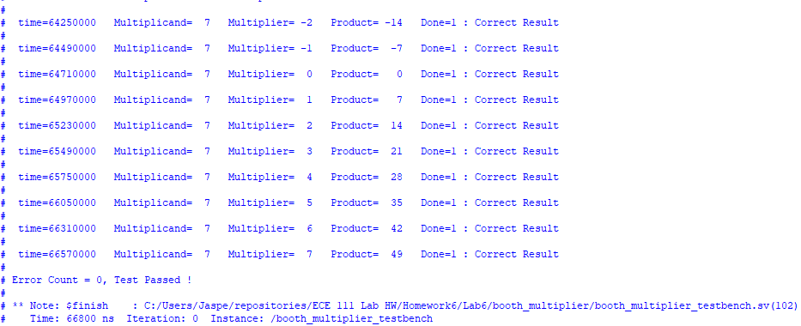
The simulation result shows all tests passed from the transcript. The above simulation wave is the first test case where you can see the next_state changes correctly between each determined test shift_reg[1:0] and update the shift_reg accordingly until the counter reaches the N count and return the product. The wave shows -8 * -8 which gives 64 in the product, the model works perfectly as a integer multiplier.

